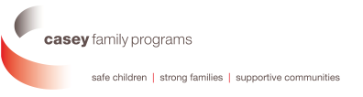

Understanding Texas’ Foster Care Capacity Crisis
July 29, 2021, 10am-3pm
AT&T Conference Center, Austin, TX

AGENDA

10:00am Opening Remarks
Anne Heiligenstein, Casey Family Programs
Katie Olse, TACFS
Commissioner Jaime Masters, DFPS

10:15am Presentation: What the data tells us about why Texas is in a capacity crisis
Katy Bourgeois, TACFS - Moderator
Jeff Cox, TACFS
Adam King, DFPS

11:30 Discussion of Significant Events
Judge John Specia, Former DFPS Commissioner
Katie Olse, TACFS

11:40am Stretch break and lunch

12:00 pm Panel: What it takes to serve a children with complex needs… and serve them well.
Katie Olse, TACFS - Moderator
Megan Zellner, Settlement Home
Jimmy Moore, Lubbock Home for Children
Angela Humphrey, Adiee Emergency Shelter
Brenda Keller, TACFS

1:00 pm Participant discussion and activity

1:30pm Panel: Innovations Across the Country
Peter J. Pecora, Moderator
Lindsey Jones, Oklahoma Department of Human Services
Melissa Lloyd, Sacramento County, CA
Mollie Greene, New Jersey Department of Children and Families
Michele Boguslofski, Teaching Family Model

2:30pm Youth and mentor perspective

3:00pm Adjourn

